Supporting Information (S1)

Table 1. Importance of components, from Principal Components Analysis of the set of 18 hydrological metrics used as explanatory variables in this study.

|  |  |  |  |  |  |
| --- | --- | --- | --- | --- | --- |
|  | **PC1** | **PC2** | **PC3** | **PC4** | **PC5** |
| Standard deviation | 2.787 | 1.995 | 1.273 | 1.079 | 0.996 |
| Proportion of variance | 0.431 | 0.221 | 0.090 | 0.065 | 0.042 |
| Cumulative proportion | 0.431 | 0.653 | 0.743 | 0.807 | 0.862 |

Table 2. Loadings across principal components for the set of 18 hydrological metrics used as explanatory variables in this study.

|  |  |  |  |  |  |
| --- | --- | --- | --- | --- | --- |
| metric | PC1 | PC2 | PC3 | PC4 | PC5 |
| MDFMDFWet | -0.068 | 0.127 | -0.647 | -0.183 | 0.210 |
| MDFMDFDry | 0.261 | -0.226 | -0.132 | -0.141 | 0.243 |
| CVMDFWet | -0.300 | -0.102 | 0.242 | -0.194 | 0.210 |
| CVMDFDry | -0.331 | -0.134 | 0.043 | 0.125 | -0.046 |
| HSPeak | -0.307 | -0.001 | -0.272 | 0.190 | -0.018 |
| HSMeanDur | 0.261 | -0.313 | -0.046 | 0.068 | -0.016 |
| CVAnnHSPeak | -0.296 | 0.063 | -0.210 | 0.082 | 0.131 |
| CVAnnHSMeanDur | 0.141 | -0.367 | 0.150 | 0.312 | 0.029 |
| LSPeak | -0.137 | 0.384 | -0.023 | 0.314 | 0.257 |
| LSMeanDur | -0.283 | -0.193 | -0.067 | -0.336 | 0.205 |
| CVAnnLSPeak | 0.095 | -0.342 | 0.069 | -0.350 | 0.330 |
| CVAnnLSMeanDur | -0.121 | -0.242 | -0.199 | 0.130 | 0.311 |
| BFI | 0.334 | -0.020 | -0.026 | 0.205 | 0.215 |
| CVAnnBFI | -0.250 | -0.286 | -0.139 | 0.160 | -0.235 |
| C_MinM | 0.200 | -0.225 | -0.403 | 0.394 | -0.045 |
| M_MinM | 0.172 | 0.159 | -0.211 | -0.233 | -0.451 |
| C_MaxM | -0.154 | -0.345 | -0.155 | -0.202 | -0.456 |
| M_MaxM | 0.259 | 0.175 | -0.246 | -0.283 | 0.066 |

Table 3. Summary statistics for trait data.

|  |  |  |
| --- | --- | --- |
| **trait** | **mean** | **SD** |
| *flowering duration (months)* | 4.72 | 2.58 |
| *leaf area (cm2)* | 28.61 | 28.05 |
| *maximum height (m)* | 19.79 | 13.98 |
| *seed mass (mg)* | 365.99 | 2078.8 |
| *SLA (cm2/g)* | 15.3 | 7.42 |
| *wood density (g/cm3)* | 0.609 | 0.13 |

Table 4. Proportional abundance of plants represented in the functional diversity analysis at each site.

|  |  |  |  |
| --- | --- | --- | --- |
| **site** | **Total cover (individuals Ha-1)** | **Represented cover (individuals Ha-1)** | **Proportion represented** |
| *1* | 8365 | 8219 | 0.983 |
| *2* | 13698 | 13643 | 0.996 |
| *3* | 28142 | 22487 | 0.799 |
| *4* | 9567 | 8177 | 0.855 |
| *5* | 3193 | 3179 | 0.996 |
| *6* | 25237 | 25140 | 0.996 |
| *7* | 14409 | 12887 | 0.894 |
| *8* | 9458 | 9384 | 0.992 |
| *9* | 16578 | 15068 | 0.909 |
| *10* | 12505 | 11118 | 0.889 |
| *11* | 42275 | 35464 | 0.839 |
| *12* | 9320 | 9320 | 1.000 |
| *13* | 25981 | 23881 | 0.919 |
| *14* | 12954 | 12007 | 0.927 |
| *15* | 11103 | 10882 | 0.980 |
| *16* | 20669 | 16540 | 0.800 |
| *17* | 25177 | 18199 | 0.723 |
| *18* | 4613 | 4219 | 0.915 |
| *19* | 3657 | 3443 | 0.942 |
| *20* | 27249 | 23889 | 0.877 |
| *21* | 23301 | 23008 | 0.987 |
| *22* | 15639 | 13730 | 0.878 |
| *23* | 10855 | 6067 | 0.559 |
| *24* | 17888 | 15538 | 0.869 |
| *25* | 3869 | 2603 | 0.673 |
| *26* | 14070 | 11862 | 0.843 |
| *27* | 17238 | 14213 | 0.825 |
| *28* | 13756 | 9638 | 0.701 |
| *29* | 7249 | 7208 | 0.994 |
| *30* | 21555 | 21483 | 0.997 |
| *31* | 7296 | 7227 | 0.991 |
| *32* | 5307 | 5307 | 1.000 |
| *33* | 19417 | 19046 | 0.981 |
| *34* | 9942 | 9782 | 0.984 |
| *35* | 8202 | 8185 | 0.998 |
| *36* | 3745 | 3607 | 0.963 |
| *37* | 13851 | 13535 | 0.977 |
| *38* | 18326 | 15187 | 0.829 |
| *39* | 8410 | 5840 | 0.694 |
| *40* | 5360 | 5283 | 0.986 |

Table 5. Proportion of species included in the functional diversity analysis for which trait values were available.

|  |  |
| --- | --- |
| **trait** | **data density** |
| *flowering duration* | 0.891 |
| *growth form* | 1 |
| *leaf area* | 0.983 |
| *maximum height* | 0.971 |
| *seed mass* | 0.868 |
| *SLA* | 0.661 |
| *wood density* | 0.672 |

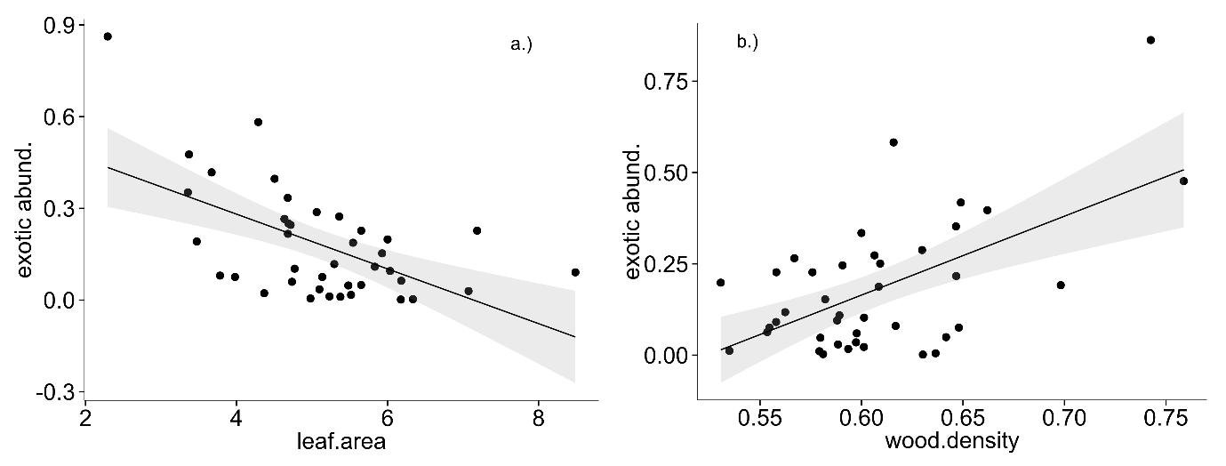

Figure 1. Relationships between exotic proportional abundance and a.) community weighted mean leaf area; b.) community weighted mean wood density.